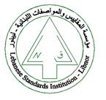
The Lebanese Standards Institution
Invites you to attend the
“Fundamentals of Project Management”
Training course

Offered by LIBNOR training center

Date: 18-19 February 2019
Time: 9:00am -4:00pm
Companies are invited to contact us to register nominated candidate
Kindly send the filled and signed application form along with your curriculum vitae to the Consulting and Training division
at the following email address : training@libnor.org or
call us on: 01-485927 ext:163
P.S.: After an approval of your application you will receive a registration e-mail confirmation

